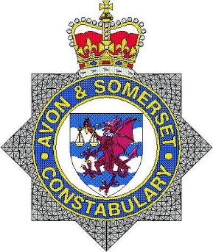
Avon and Somerset Constabulary
www.avonandsomerset.police.uk

Police Report
May 2021

Bishops Lydeard Crime Stats

There were 170 calls to 999 and 101 on the Wellington rural beat in May 2021.
8 calls into 101 and 999 for Bishops Lydeard for the month of May 2021.

These calls involved-
- 1 Burglary – This was a mental health incident
- 1 Shop theft – This is an ongoing investigation
- 1 Theft
- 1 Criminal damage

- 1 Affray, 2 Violence against a person, 1 possession of an offensive weapon – Please don’t be alarmed this involved one person and was one incident.

Reports of Antisocial Behavior
There was 1 call in May for Anti-social Behaviour. This was a neighbour disagreement.

What’s been done?
Patrolling hot spots around the Bishops Lydeard to discourage anti-social behavior, drug use and supply.
I will be continuing with my hot spot patrols.

Information sought
If you have information concerning the injury of horses please call 101 and quote 5221104679

Thank you

